Performance Test of a Fluidic Momentum
Controller in Three Axes

Spacecraft Attitude Control

Amanda Kelly
amanda.l.kelly@mail.utexas.edu
713-819-1211
Dr. Robert H. Bishop
rhbishop@mail.utexas.edu
512-471-4596





The University of Texas at Austin
Department of Aerospace Engineering and Engineering Mechanics
W. R. Woolrich Laboratories
1 University Station
Austin, Texas 78712

_________________________________
Dr. Robert H. Bishop
Faculty Advisor

Abstract
Stabilization of a spacecraft through active attitude control is essential for a successful mission. Maintaining an optimal spacecraft orientation is necessary for power generation and communication capabilities. A well-designed controller also has the capability to provide a spacecraft with necessary heating and/or cooling conditions. For these and many other reasons the space industry demands highly efficient and reliable attitude controllers for current and future missions.

A Fluidic Momentum Controller (FMC) is a highly attractive avenue to pursue, offering possible improvements in many of these areas. The basic concept of the FMC is derived from the law of conservation of angular momentum. An FMC controls attitude by accelerating fluid through loops and imparting torques on the spacecraft. FMCs differ from conventional attitude controllers, in that other control systems tend to be more bulky and require a heavy solid mass to be spun to create angular momentum. In comparison with the traditional Control Moment Gyro and Momentum Wheel, an FMC provides improvements in power, weight, and volumetric efficiencies.

A performance test of an FMC on the KC-135A will explore the capability to control a small mock satellite in three axes under microgravity conditions. Six accelerometers will provide input data to be manipulated to determine rotation rates and angle magnitudes. These values will be used as inputs to a control program that will maintain an initial attitude after disturbances are applied to the satellite. Memory cards within the control system will record all inputs and outputs (e.g. control variables) for later analysis. The results will be examined for consistency. Video footage will also be taken to provide a qualitative assessment of the experiment. A final report providing a detailed description of the performance test will be submitted to NASA.
Table of Contents
List of Tables iv
List of Figures iv
List of Acronyms v
Flight Week Preference vi
1.0 Technical Description 1
1.1 Introduction 1
1.2 Test Objectives 2
1.3 Test Description 2
1.3.1 Apparatus Design 2
1.3.2 Ground Testing and Calibration 4
1.3.3 Data Acquisition and Analysis 4
1.3.4 Justification for the Microgravity Environment 8
1.3.5 Follow-Up Flight 9
1.4 References 9
2.0 Safety Evaluation 10
2.1 Flight Manifest 10
2.2 Experiment Description 10
2.3 Equipment Description 11
2.3.1 Pumps 11
2.3.2 Accelerometers 12
2.4 Structural Design 12
2.4.1 FMC Free-Flyer 12
2.4.2 Alternative FMC Non-Free-Flyer 13
2.5 Electrical System 14
2.5.1 FieldPoint 14
2.6 Pressure System 17
2.7 Laser System 17
2.8 Crew Assistance Requirements 17
2.9 Institution Review Board 17
2.10 Hazard Analysis 17
2.11 Tool Requirements 18
2.12 Ground Support Requirements 19
2.13 Hazardous Materials 19
2.14 Procedures 19
2.14.1 Ground Operations 19
2.14.2 Pre-Flight 19
2.14.3 In-Flight 19
2.14.4 Post-Flight 20
3.0 Outreach Plan 21
3.1 General Audiences 21
3.1.1 University of Texas at Austin Outreach Events 21
3.1.2 Houston Museum of Natural Science 22
3.1.3 The Science Place 23
3.2 Primary and Secondary School Outreach Activities 23
3.3 Publications 24
3.4 Team Webpage 24
4.0 Administrative Requirements 25
4.1 Institution’s Letter of Endorsement 25
4.2 Supervising Faculty Statement 25
4.3 Budget 25
4.4 Funding 27
4.5 Institutional Review Board 27
4.6 Institutional Animal Care and Use Committee 27
4.7 Parental Consent Forms 27
Appendix A: Institution’s Letter of Endorsement and Supervising Faculty Statement 28
Appendix B: Outreach Letters of Committal 32
Appendix C: Specification Sheets for Various Components 41
Appendix D: MATLAB Moment of Inertia and Angular Momentum Code 49

List of Tables
Table 1. Possible Hazards from Test Apparatus 18
Table 2. Estimated Budget for Texas FLOAT Project 26

List of Figures
Figure 1. Isometric View of Test Apparatus Preliminary Design 3
Figure 2. Top View of Test Apparatus with Reference Frames Defined 5
Figure 3. Basic Conceptual Controller Design, [Dorf, 2001] 7
Figure 4. JABSCO 59500-0012 Centrifugal Pump 11
Figure 5. PCB Piezotronics' Model 333B52 Accelerometer (magnified) 12
Figure 6. Modular Design of FieldPoint Hardware 15
Figure 7. Electrical System Schematic 16
Figure 8. Hydro Gyro 22

List of Acronyms
AIAA American Institute of Astronautics and Aeronautics
ASE Aerospace Engineering
CAD Computer Aided Design
CMG Control Moment Gyros
EAC External Advisory Committee
EUREKA Enhancing Undergraduate Research Knowledge, and Access
FIG Freshman Interest Group
FLOAT Fluid Loop Orientation/Attitude Test
FMC Fluidic Momentum Controller
HMNS Houston Museum of Natural Science
IMU Inertial Measurement Unit
MSDS Material Safety Data Sheet
NI National Instruments
NIFP National Instruments FieldPoint
PC Personal Computer
PVC Polyvinylchloride
RGSFOP Reduced Gravity Student Flight Opportunities Program
SURGe Science Undergraduate Research Group
UT The University of Texas

Flight Week Preference
The FLOAT team’s preferred flight week is the week beginning April 1, 2004 and ending April 10, 2004. The second choice is the week of The University of Texas’ spring break, the week of March 18, 2004 through March 27, 2004. The remaining two spring 2004 flight weeks (Week 1 and Week 4) are also options as potential flight weeks for the FLOAT team.

The FLOAT team does have three graduating seniors and therefore requests to fly during the spring 2004 school semester. A summer flight week could be arranged if necessary.

Technical Description
The test apparatus design and project description are provided in the following subsections. The motivation behind the project is developed and the desired goals are stated.

Introduction
Spacecraft attitude control is a core subsystem ultimately responsible for sustaining the life of a spacecraft. The ability to control the orientation of a spacecraft plays a vital role in many mission requirements. The requirements for mission success affected by spacecraft attitude control are too numerous to list in full. A few major ones include generating power from the solar arrays, maintaining communication signals, providing the ability to maintain a prescribed mission altitude and/or attitude, and the heating and cooling of key system components. Complete failure of a mission could occur if the importance of any one of these functions and their relation to spacecraft orientation is underestimated. Stabilization of the spacecraft can also dictate the clarity of photographic images, and such a seemingly small defect can render a multi-million dollar mission useless. It is for all of these reasons that the space industry demands highly reliable, efficient, and low-cost attitude controllers, tailored to fit the needs of specific missions.

In general, all spacecraft attitude control systems implement the principle of conservation of angular momentum to stabilize the spacecraft against disturbance torques. Conventional attitude controllers, such as Control Moment Gyros (CMGs), provide momentum to the spacecraft by rapidly spinning a rotor. One of the many advantages of a Fluidic Momentum Controller (FMC) is the flexibility of its application. For instance, since an FMC is a more light-weight and less bulky system than CMGs, it could be implemented on a larger array of spacecraft missions. The fluid loop radius can be varied to best fit the needs of the given spacecraft and mission.

Since an FMC could be implemented on smaller spacecraft, FMCs could be used in the rapidly growing field of micro- and nano-satellite technology. Micro- and nano-satellites are being used more frequently because of the cost benefits associated with sending smaller and lighter spacecraft to orbit. However, the size and weight limitations of such satellites prevent conventional control systems from being implemented in their design. A possible solution to the lack of such a major subsystem could be FMCs. Increased research is required if that is to be achieved.

FMCs possess other advantageous features as well. A design of an FMC with a sufficiently large fluid loop radius promotes energy efficiency by requiring less rotational velocity and system mass. CMGs often require complex multi-unit systems to achieve adequate control torque. CMGs also require vibration isolation platforms since they operate in a state of high energy density [Maynard, 1984]. The FMC, located on the periphery of the spacecraft is capable of functioning at a low energy density. In return, the FMC transmits minimal vibration to the structure, and is more efficient per unit mass or volume than a CMG [Maynard, 1984].

Some possible auxiliary functions of the FMC may also prove to be beneficial. For example, water has the capacity to absorb much of the waste heat from the spacecraft. The large surface area of the piping can be used as a radiator to expel excess heat [Maynard, 1984]. Also, by placing water reservoirs along the fluid loops, a secondary balancing effect could be created facilitating the primary function of active attitude control [Maynard, 1984].

Not only is the FMC a viable option in theory, it is also a highly appealing option in practice. Yet, this device has never been thoroughly researched and developed. The concept for an FMC was developed in the 1980s, and now lies latent in the paper design of the Delta Space Station, never reaching the manufacturing and testing phase [Maynard, 1984]. FMC’s applicability was far more limited during the previous era of large spacecraft due to limitations in pump size and flow rate. The evolution of micro- and nano-satellites has now created a potential market for this technology.

Spacecraft attitude control is a quickly evolving technology. It is imperative that research for new attitude control technologies is further increased to provide the tools for continued advancement in space technologies.

1.2 Test Objectives
The Fluid Loop Orientation/Attitude Test (FLOAT) team proposes to conduct the performance test of an innovative approach to attitude control. FLOAT’s objective is to perform the test of an FMC in microgravity. It is desired that a successful test will provide motivation for increased research into FMCs as an economical, light, and efficient alternative control system to other current methods.

Test Description
The following subsections describe the general design of the test apparatus, the ground testing of the system, the method of data acquisition, manipulation and analysis, and the importance of conducting the experiment in microgravity.

Apparatus Design
The apparatus to be tested is proposed as a free-flyer. A caged or gimbaled system would produce constraints, which would defeat the purpose of the performance test of a control system. For further justification, see section 2.4.

An illustration of the apparatus design is provided below in Figure 1. The main structure will be a 1 foot by 1 foot by 1 foot cubic structure. The faces of the cube will be thin Lexan, allowing the apparatus to be transparent and lightweight. The edges of the cube will be sealed with a rubber cushioning and hinged together. All sharp edges of the structure will be padded to prevent crew member injury. An accelerometer will be placed at the center of each face in order to determine the attitude at any instant in time. Two 12-V batteries will be contained inside the cube to provide electrical system power. Plastic fluid loops containing water will be mounted on the six faces of the cube. Each fluid loop will be completed by centrifugal pumps. Water containment will be three-fold. The water will first be enclosed by the plastic loops. A thin plastic film will then be wrapped around the loops to further shield the electrical system. The outer casing of the structure will provide the last barrier between the water and the KC-135A cabin environment.
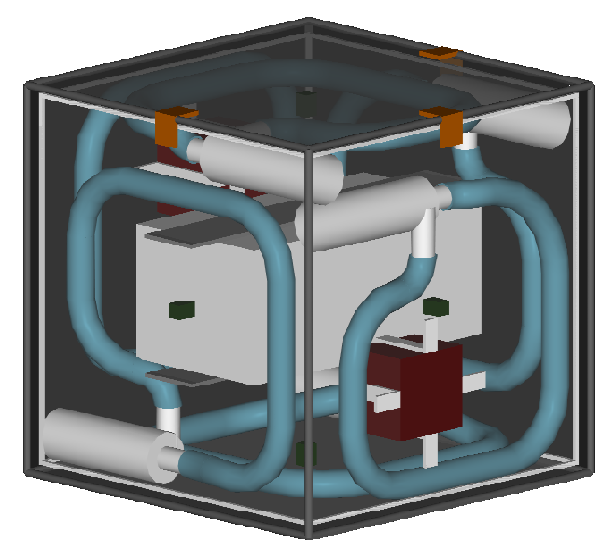
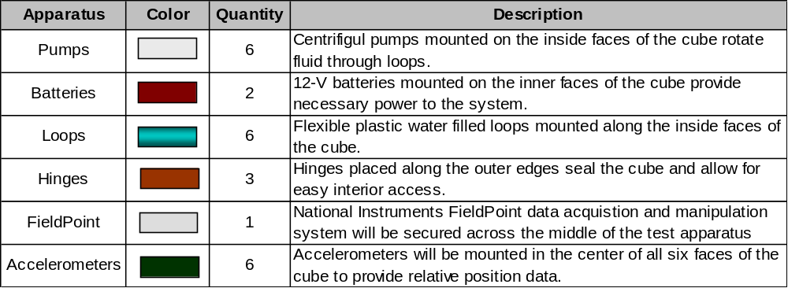
Figure 1. Isometric View of Test Apparatus Preliminary Design

The data acquisitions, analysis, and control system hardware will be securely mounted in the center of the cube. The six centrifugal pumps will be controlled by National Instruments (NI) FieldPoint (NIFP). NIFP is an integrated, stand-alone modular distributed input/output system. NIFP will implement a LabVIEW program that will control the apparatus. The data will be stored in memory cards and will be downloaded to a personal computer (PC) after the KC-135A flight. Therefore, no external computing system will be required during the flight.

The experimental hardware will not exceed 50 pounds in weight and will be secured to the floor of the KC-135A cabin during the climb and descent portions of the flight.

1.3.2 Ground Testing and Calibration
Prior to flight testing the experiment, ground testing will be conducted in order to calibrate the equipment. Ground testing of the experiment will be conducted by suspending the apparatus from each of its axes and powering the pumps for a prescribed time. During this time, the angular rotation will be measured. Also, a bias is expected from the accelerometer data due to inaccuracy of the measurements. Therefore, during ground testing of the apparatus, this bias will be examined and efforts will be made to minimize its effect. Methods for reducing accelerometer errors will be further discussed in the Data Acquisition and Analysis section. Once the system has been fully calibrated, it will be ready for the flight test.

Also, following the design stage of the control software, a simulation will be created that will test the behavior of the FMC in response to various disturbances. An iterative process will be used in an attempt to optimize the code before flight. The simulation will be used to provide insight to some expected results that may be seen.

1.3.3 Data Acquisition and Analysis
As mentioned before, the data acquisition and manipulation will be controlled by NIFP. NIFP is a stand-alone data acquisition system that is capable of interfacing with NI’s LabVIEW software. LabVIEW software will be the primary data manipulation software to be used in the FLOAT project.

The aim of the FLOAT project is to prove that the yaw, pitch, and roll of the test apparatus can be simultaneously controlled with a fluid loop control system. The primary experiment to be conducted will be completed as follows:
- the test apparatus will be picked up from the floor of the cabin as microgravity begins,
- the LabVIEW data acquisition and control programs will be initiated,
- the test apparatus will be spun slowly to provide an initial disturbance, and
- the test apparatus will be closely monitored to ensure the cube does not stray too far from the center of the cabin.

The desired goal of the project is to design a control system that, after an initial disturbance, will be able to return the apparatus to its original position within 20 seconds of microgravity. However, it is understood that for a free-flying experiment, only a few seconds of unobstructed free-float is likely to be achieved. Therefore, the minimum goal is to prove that the FMC will actively respond to disturbances and attempt to return the apparatus to its original orientation.

When the LabVIEW program is initiated, real-time data will be retrieved from the accelerometers. The accelerometer data obtained will be manipulated to provide position (or angular rotation) coordinates. These coordinates will then be used as inputs to the control system. The control system will turn the pumps on and off. The amount of time the pumps are powered on or off will be the primary method of control. By powering the pumps for longer periods of time, greater rotation angles can be achieved.

The orientation of the test apparatus at any instant in time will be determined from the data retrieved. Relative angular position data calculated from the accelerometer readings will show that an overall change in orientation occurred. This change of orientation will be corrected by the control system, while the accelerometers will continue to retrieve data for future inputs.

To determine the magnitude of the rotation about each axis, the relationship between a non-rotating, “inertial” reference frame placed at the center of mass of the test apparatus, and a reference frame that does rotate with the rigid body must be found. A graphical depiction of the problem to be solved can be seen below in Figure 2.

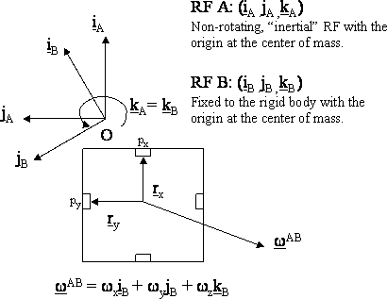
Figure 2. Top View of Test Apparatus with Reference Frames Defined

In Figure 2, accelerometers are represented as small rectangles on the inside faces of the cube. It is the accelerations of these points, p_{x} and p_{y}, that are of interest in the given control problem. For a general angular velocity of the B frame relative to the A frame, ω^{AB}, the velocity of point p_{x} can be determined by

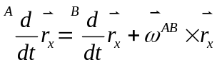 (1) [Kaplan, 1976].

In reference frame B, since it is rotating with the body, the first term on the right side of the equation is zero. Only the cross product term is left, therefore, if equation 1 is differentiated, a result for the acceleration of the point is achieved. The acceleration of point p_{x} is given by

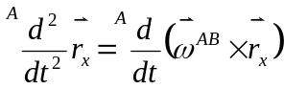 (2).

The result from evaluation of the right hand side gives

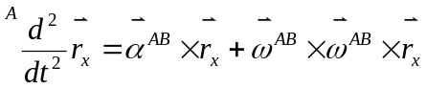 (3).

After evaluating each of the terms on the right hand side, the general acceleration of point p_{x} is achieved and is given by

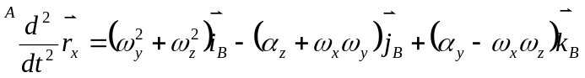 (4).

Equation 4 is stated as the acceleration of the point p_{x} as seen in the A frame coordinated in the B frame. Similar expressions can be obtained for both point p_{y} and p_{z} on the other faces of the cube.

Finally, by imposing constraints due to the limitations of the unidirectional accelerations, a system of equations emerges which can be solved. The accelerometers shall be placed on the faces as to only measure the centripetal acceleration of the points in p. Thus, the only contribution for each of the accelerations will be in the same direction as the moment arm (i.e. r_{x} will correspond to a sensed acceleration in the i direction). With this unidirectional condition imposed, the acceleration equations become

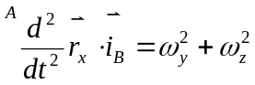 , 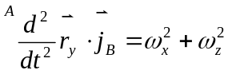 , 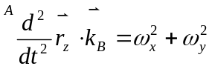 (5a, b, c).

The left side of these equations is the measured centripetal acceleration and the system of three equations and three unknowns can be solved for ω_{x}, ω_{y}, and ω_{z}. Once these values are known, the values of total rotation can be solved through numeric integration. The relative angular positions are given by

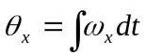, 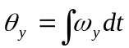, 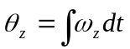 (6a, b, c).

These rotations will be used as inputs to a control system which will control the angular momentum produced by the fluid loops in the test apparatus.

Another concern when designing a controller of this type is accounting for angular acceleration of the system. From equations 4 and 5, it can be seen that the accelerometers cannot account for this angular acceleration. However, since the angular acceleration is the time rate of change of the angular velocity, the angular acceleration can be numerically approximated. After the angular velocity is calculated at two instances in time, the angular acceleration can be approximated by

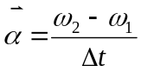 [Bedford, 2002].

Finally, biased and noise errors associated with accelerometer measurements should be accounted for to create an accurate control system. Error propagation is unavoidable in any measurement system. However, efforts can be made to reduce the magnitude of the error. The FLOAT team plans to attempt to reduce the error associated with the acceleration measurements by obtaining values for the acceleration from two accelerometers placed on opposite faces of the test apparatus. The acceleration data receive will be averaged in order to dampen the affects of the bias and noise errors. An additional benefit associated with the use of two accelerometers per measurement is a more robust system. If one of the accelerometers malfunctioned, there would still be a second accelerometer from which data could be retrieved.

Now that the calculation of the angular acceleration, angular velocity, and total angular change can be approximated, these values can be used as inputs to a control system and reaction torques can then be applied.

The basic conceptual design of the block diagram for the control system is provided below in Figure 3.

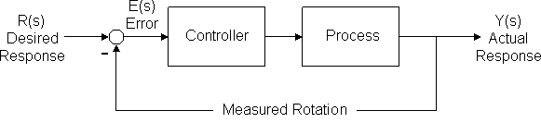
Figure 3. Basic Conceptual Controller Design, [Dorf, 2001]

The control system will apply the required torques to rotate the apparatus from its measured offset orientation back to its original orientation. The reorientation will be accomplished through application of the law of conservation of angular momentum. This law relates the time rate of change of angular momentum to torque. Therefore, if the angular momentum of the system is changed, a torque will be exerted, and a resulting rotation is produced. The torque due to a change in angular momentum is given by

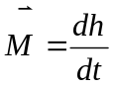 (8)

where 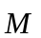 is the torque, or moment, and is the angular momentum. This relationship is the basis of how the fluid loops will control the apparatus. A moment may also be represented by

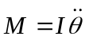 (9)

From equation 5, the angular rotation can be controlled from an angular momentum applied by the fluid loops.

The acceleration and position data will be saved on NIFP memory cartridges. These data will later be used to verify that the apparatus did in fact attempt to maintain its prescribed attitude. A video camera will also be used during the flight test, and the recorded images will be examined following the flight. These two methods of data acquisition will be the main sources for the final analysis of the experiment.

Once the test has been completed, the data can be analyzed to determine if the test was a success. If the test does not provide the expected results, the data will be examined for consistency. If any biases exist in the data, an attempt will be made to explain them in respect to why they occurred. In reality, due to the inherent inaccuracy of the accelerometers, some degree of a biased error is expected.

1.3.4 Justification for the Microgravity Environment
Microgravity is imperative for conducting the performance test of the FMC. Gravitational torques are much larger than the torques that the FMC is design to counteract, therefore, testing of the FMC in 1-g becomes extremely difficult.

Simulations of the FMC in gravity have not yielded the desired accuracy for the data collected. One apparatus tested at The University of Texas (UT) by undergraduate students used a helium balloon. To overcome the effects of gravity, the helium balloon needed to have a large volume and a low weight. The large volume and resulting surface area introduced a sufficient drag effect across the balloon. Although, the drag effect is not eliminated on-board the KC-135A, the test object will be a much smaller spacecraft, thus making drag effects almost negligible. Also, the nature of the helium balloon rendered the experiment too fragile for sufficient testing.

The second type of apparatus developed by undergraduate students at UT implemented an air cushioning system to suspend a test object. This test method also proved to be ineffective. Difficulties arose in maintaining an even distribution of air over the test object while also keeping the apparatus’s weight low as not to exceed the reaction force due to air pressure [Krause, 1987]. Again, the limitations of the gravity environment caused the experiment to fail as the controller could not be tested.

Another possible consideration for a 1-g test is a gimbaled system. However, a gimbaled system would not be a practical design for testing in a 1-g lab. The pumps would not be capable of producing sufficient angular momentum to overcome torques induced by asymmetries in the design. Even with the use of more powerful pumps to force a higher flow rate, problems could arise in the form of cavitation in the loops, thus causing a stall effect.

A microgravity environment is the only way to accurately test an FMC. This environment will allow the testing of three axes, and the central body will experience minimal drag effects due its small size. To further advance the knowledge associated with a fluidic control system, the next step is to test the controller in the environment in which it will actually be used.

1.3.5 Follow-Up Flight
To the FLOAT team’s knowledge, the experiment to be conducted has not previously been flown as a KC-135A microgravity project.

1.4 References
Bedford, Anthony; Fowler, Wallace. Engineering Mechanics: Dynamics. Upper Saddle River: Prentice Hall, 2002.

Dorf, Richard; Bishop, Robert. Modern Control Systems. Upper Saddle River: Prentice Hall, 2001.

Duncan, E., et. al., “Fluidic Attitude Control Experiment,” Department of Aerospace Engineering and Engineering Mechanics, University of Texas at Austin, May 3, 1996.

Hinders, K., et. al., “Fluidic Momentum Controller Project,” Department of Aerospace Engineering and Engineering Mechanics, University of Texas at Austin, August 13, 1993.

Kaplan, M. H., Modern Spacecraft Dynamics & Control, Wiley, 1976.

Krause, L., et. al., “An Expandable Structure for Use in Testing the Fluidic Momentum Controller,” Department of Aerospace Engineering and Engineering Mechanics, University of Texas at Austin, December 8, 1987.

Maynard, R., “Fluidic Momentum Controller,” NASA-Johnson Space Center, June 1984.

Wiesel, W. E., Spaceflight Dynamics, 2nd-Edition, McGraw-Hill, 1997.

2.0 Safety Evaluation
The safety requirements of the RGFSOP have been addressed in the following subsections. All subsystems possess minimal safety concerns.

2.1 Flight Manifest
Proposed Flyers:
- Amanda Kelly
- Patrick Smith
- Brad Steinfeldt
- Shara Walenta

Proposed Alternate Flyer:
- Chad Zaruba

Ground Crew:
1. Michael Davies

Team Journalist:
There is currently no team journalist. The team has contacted News 8 Austin and the Austin American Statesman in search of a reporter to cover the team’s flight experience. Once final approval has been granted, the team will contact the Reduced Gravity Student Flight Opportunities Program (RGSFOP) selection committee.

2.2 Experiment Description
The Fluid Loop Orientation/Attitude Test (FLOAT) team plans to conduct an experimental performance test of a Fluidic Momentum Controller (FMC). The performance test will include both quantitative and qualitative analysis to investigate an alternative attitude control system. The attitude of a satellite can be changed by pumping fluid through a loop which generates a change in angular momentum. FLOAT will use the fluid loops to counter-balance disturbance torques and maintain a desired attitude. The primary objective of the performance test will be to demonstrate the capabilities of an automated FMC. This experiment has never been previously investigated as a KC-135A microgravity research topic.

The apparatus will be tested in a simple, repeatable process. With each parabola, one flyer of the FLOAT team will initiate the control system and proceed to slowly spin the free-flying apparatus. The motion of the test apparatus will be closely monitored at all times to prevent the structure from impacting any obstacles. When the control system is activated, it will proceed to record all measurement readings and all real-time control loop decisions. The data recorded will be used for quantitative analysis. The experiment will also be video taped and the footage will be used for further qualitative analysis.

Ideally, the FLOAT team aims to have the test apparatus return itself to its original position within 20 seconds. However, it is understood that for a free-flying experiment, only a few seconds of unobstructed free-float is likely to be achieved. Therefore, a more realistic goal is to prove that the controller will actively respond to disturbances and make attempts to return itself to its original orientation.

2.3 Equipment Description
The equipment to be used for the FLOAT project has been thoroughly researched to determine the best choice for implementation. No safety issues were found and specification sheets are provided in Appendix C for reviewer’s edification.

2.3.1 Pumps
Several pumps were considered when deciding upon which would be the best for the FLOAT project. After much consideration, JABSCO model number 59500-0012 centrifugal pumps were chosen. These pumps have an internal impeller that accelerates the fluid and forces the flow. The JABSCO pumps are optimal for the FLOAT project because of their small size, light weight, and capability to deliver relatively high flow rates. In addition, the JABSCO pumps have some important safety measures incorporated into their design. The JABSCO 59500 series pumps are rated for 15 liters per minute of continuous fluid delivery at a nominal value of 1.7 psi for up to 2,500 hours. The inlet and outlet ports are 0.75 inches in diameter with barbed connections that reduce the risk of the tubing slipping from the connection points. Also, the pumps have been IP 53 and ISO 8846 rated. These ratings mean the pump may withstand a 60-g shock and that its motor will not ignite surrounding gases, respectively.

Figure 4 below shows the pump selected. The pump dimensions are 5.72 inches long by 2.53 inches high by 3.13 inches wide. The weight of the pump is 0.83 pounds. The pump’s motor will be powered with 12-V DC. An upper limit for the current will be created by a 2-A fuse to prevent pump overheating.

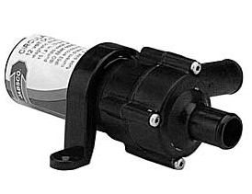
Figure 4. JABSCO 59500-0012 Centrifugal Pump

The only drawback of the JABSCO pump is that it does not perfectly lend itself to the FLOAT project design. The pump’s inlet and outlet ports are not in line with one another which affected the entire test apparatus design. The plastic loops were forced to be non-circular and the radius was also decreased due to the size of the pumps. However, the JABSCO pumps are the best design choice at the present time. The FLOAT team has not ruled out the option of implementing another pump and is still actively looking for a possible alternative solution.

2.3.2 Accelerometers
National Instruments’ (NI) Field Point (NIFP) hardware will acquire acceleration data from six single-axis accelerometers mounted with adhesive at the center of each of the test apparatus’s faces. By having six accelerometers on adjacent faces, NIFP is able to detect rotation about any axis.

PCB Piezotronics’ model 333B52 has been selected as the preferred accelerometer. The accelerometer was selected because it met compatibility, sensitivity, phase response, and durability requirements of the project. The accelerometers output a biased voltage between 7 and 12 Volts. They are calibrated to 1000 mV per g with a measurement range of ± 5g. Additionally, the accelerometers have a phase response of 2.5 to 3000 Hz, which is a sufficient spectrum for this project’s scope. Finally, a concern existed with the maximum allowable shock value the accelerometer could withstand. The PCB accelerometer is able to withstand a ±4000 g shock, which is more than adequate for KC-135A conditions.

In addition to meeting the FLOAT project data sensing requirements, the PCB accelerometer adheres to the space constraints of the project. The dimensions of the accelerometers are 0.45 inches by 0.68 inches by 0.45 inches. The selected accelerometer can be seen in Figure 5 below.

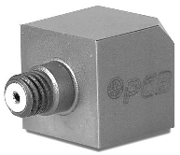
Figure 5. PCB Piezotronics' Model 333B52 Accelerometer (magnified)

The FLOAT team is also currently in the process of researching Inertial Measurement Unit (IMU) gyros as an alternative to the use of accelerometers for attitude determination.

2.4 Structural Design
The test apparatus for the FMC consists of a cube shaped box with test equipment included inside. The equipment inside the cube includes the NIFP hardware, PCB accelerometers, JABSCO centrifugal pumps, fluid loop tubing, and batteries.

2.4.1 FMC Free-Flyer
A Computer Aided Design (CAD) drawing of the structure is provided in Figure 1 above. Safety features have been built into the design of the test apparatus. The FLOAT team has designed a cube with equal side dimensions of 1 foot by 1 foot by 1 foot. The six faces of the cube will be made from 0.093 inches Lexan, allowing the structure to be transparent and lightweight. Lexan is produced by GE Structured Products and was chosen because it is 250 times stronger than glass and 30 times stronger than regular acrylic. It still remains lightweight and transparent, which are both greatly beneficial. Three of the edges will be hinged to allow easy access to the internal components. The hinges will be made of zinc and will be attached with bolts to prevent any shearing or failure of the Lexan sidewalls. Each edge of the faces will have a D-shaped rubber seal to prevent leakage of the internal fluid should the water escape the fluid loop tubing. All sharp edges of the cube will be padded with a soft material as a safety precaution. Each face will have a loop and pump mounted on the inside wall. The pumps will be mounted with two bolts through the face while the loops will be fastened with six bolts (two bolts every 90 degrees). The orientation of the pumps on opposite faces will be such that the angular momentum vectors produced by the rotating fluid will act in opposing directions. The fluid loops are made of polyester braided polyvinylchloride (PVC) hoses giving extra protection against leaks. Also, a thin plastic film will also be wrapped around the tubing for an additional barrier between the water and electrical components. The pumps provide flow rates of 15 liters per minute, which is high enough to gain control of the apparatus a short time span. A single axis accelerometer will be placed on each face and will continuously determine instantaneous attitudes of the structure. The accelerometers will be mounted directly to the face with adhesive. Two rigid flat plates will span the apparatus. The two plates will mount into the sides of the test apparatus by sliding through a rubber padded slot and then being secured with fasteners. The NIFP system will be mounted to one of the flat plates on the bottom with screws, while the top plate will secure the system within the cube. Additionally, two motorcycle batteries will be symmetrically mounted with cover plates on opposing faces of the cube.

During the ascent and descent of the KC-135A, the structure will be strapped down to the floor of the aircraft. One flyer will be responsible for monitoring the motion of the test apparatus during all phases of the parabola.

2.4.2 Alternative FMC Non-Free-Flyer
In the event the FLOAT project is not selected as a free-flyer, an alternative approach to testing the FMC in microgravity is to provide a gimbaled system. FLOAT proposes to create a gimbaling structure that would be anchored to the floor of the KC-135A.

A light weight metal will compose each of the three gimbals. A semi-rigid connection between the FMC test apparatus and the gimbals will be achieved through a socket joint connection between two of the faces and the inner gimbal. The post out of the z-axis will have a bearing with the outer gimbal allowing almost frictionless rotation. The base of the post will have four bolt-down slots for anchoring the gimbaled structure.

The viability of the test is preserved with the use of near frictionless bearings with light weight gimbals for each axis. However, the moments of inertia of the structure would be increased, possibly with cross terms. The increase in the moment of inertia of the structure would not provide as accurate results as would be achieved in a true free-flying experiment. Also, while the friction from the bearings in the gimbal would be minimized, some amount of friction will still exist altering the results. A gimbaled system could not be accurately tested in a 1-g laboratory either since the weight of system components, not just the mass, would greatly alter the results. Therefore, the preferred choice of the FLOAT team is to be picked as a free-flyer experiment.

2.5 Electrical System
NIFP hardware will house the electrical system and tailor it to fit the FLOAT team’s application. No additional circuitry is necessary for the test-apparatus. Two 12-V DC motorcycle batteries, the only electrical components not purchased with the NI system, will power the control system.

2.5.1 FieldPoint
The control system will be automated with NIFP, a stand-alone modular distributed input/output system. The hardware will be secured at the center of the cube structure. LabVIEW will be the main programming software used to implement the data acquisition and controller programs and will be uploaded to the NIFP system. No host computer will be required for the FLOAT team’s real-time embedded application.

The integrated system is composed of individual modules, each with unique specifications capable of accepting inputs and providing outputs. The modules will be built into a backplane, essentially a platform capable of housing four modules. This configuration can be seen in Figure 6 below. Sensors can be directly connected to the modules. The FLOAT team’s application requires three modules: one control module in which the LabVIEW software will be downloaded, one to accept the acceleration data from the accelerometers, and one to output pump commands. The output module will provide commands to the pump in the form of voltage, powering the pumps for specified amounts of time that are determined by the controller. NI connector blocks will merge the individual modules to integrate the overall system.

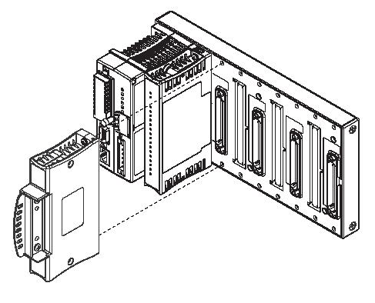
Figure 6. Modular Design of FieldPoint Hardware

A schematic of the electrical system is provided below in Figure 7. NIFP requires a power source of 11- to 30-V DC and a minimum of 15 W. Power for the FLOAT team’s system will be derived from two 12-V DC motorcycle batteries. One battery will be connected to the control module and this module will filter and regulate the power distributed to each individual module. The output module will be supplying voltages to the pumps and may require its own 12-V battery. The controller module receives the accelerometer readings, determines the necessary torques to provide to the system, and provides commands to the output module for pump manipulation. NIFP makes real-time decisions at 100 Hz and should provide a sufficient data sampling rate for the FLOAT team’s application.
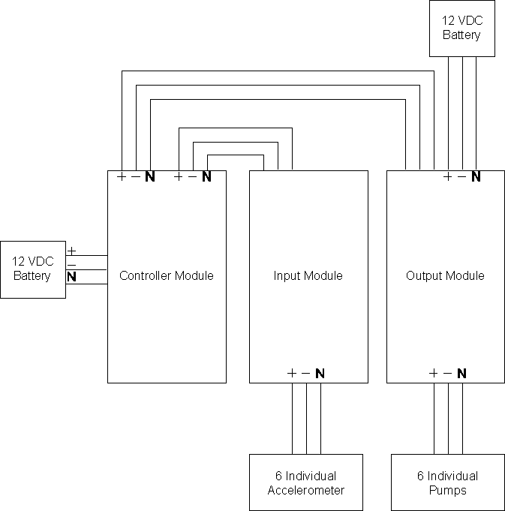
Figure 7. Electrical System Schematic

NIFP will not only make decisions in real-time, it will also store data in memory cartridges, NI Compact Flash cards. The data of interest to the FLOAT team is essentially a recording of the decisions made by the controller and angular rates measured. Acceleration measurements will be recorded as well as the amount of time the voltage is sent to the pumps. The voltage sent to the pumps will be constant because it is the amount of time the pumps are turned on that is being varied by the controller. The FLOAT team is currently looking into sensors that can be placed in the fluid flow. While the flow rate should theoretically be a fixed constant, sensors will record the real value to be used in later analysis. All stored data will be downloaded onto a PC after the KC-135A flight for thorough analysis.

2.6 Pressure System
In order to generate flow in the fluid loops, FLOAT will use centrifugal pumps manufactured by JABSCO. The pumps are low pressure, high flow rate models that minimize the risk of tubing slipping from the connection points. The maximum operating pressure for the proposed pump is 2.9 psi. If the pressure were to exceed this value, the pump would not be able to supply fluid to the loop and would shut down. 2.9 psi is a maximum value while the nominal operating pressure is 1.7 psi. With such low pressures, even in the event of cabin depressurization, the pump system is not a significant pressure concern and a relief valve is deemed unnecessary.

2.7 Laser System
No laser system will be implemented in the experiment.

2.8 Crew Assistance Requirements
No crew assistance will be needed for the experiment.

2.9 Institution Review Board
Not applicable.

2.10 Hazard Analysis
Careful analysis of the FMC device has shown that it is a safe alternative to other means of control; however, there are possible hazards associated with any device. Table 1 below provides a listing of all foreseeable hazards, their reason(s) for occurring, their consequences, and how the problem will be solved.
Table 1. Possible Hazards from Test Apparatus
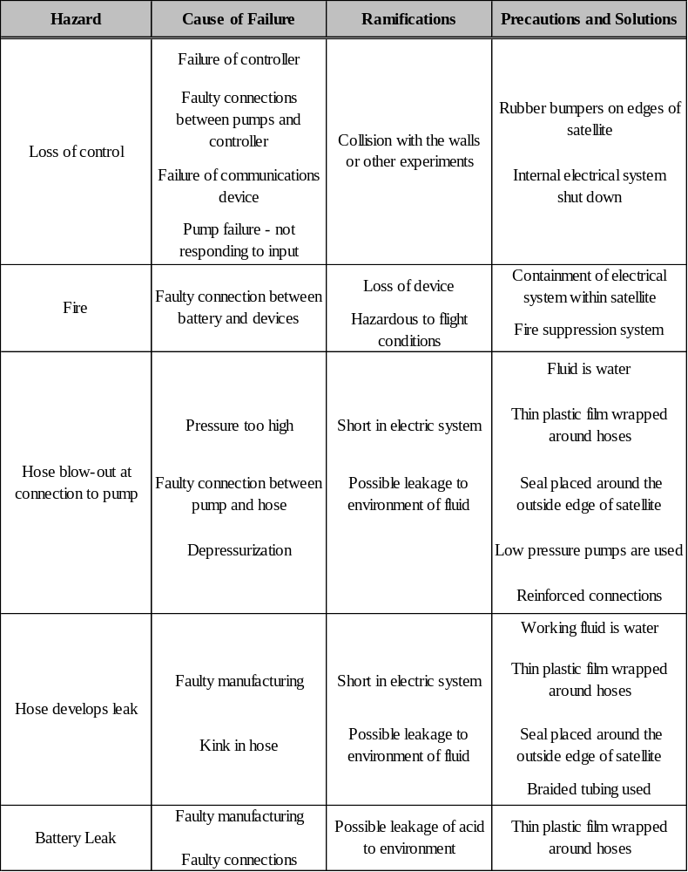

2.11 Tool Requirements
The test apparatus will be relatively simple, and will require the use of only a few construction/maintenance materials. A list of the expected materials is provided below.
1. Screwdrivers
2. Pliers
3. Socket wrench and sockets
4. Wrenches
5. Wire cutters and wire stripper
6. Voltage/current meter

2.12 Ground Support Requirements
No ground support will be required. Ground testing will be conducted in laboratories at The University of Texas at Austin prior to leaving for Houston. A final check will be conducted once in Houston to ensure system components are working properly.

2.13 Hazardous Materials
The FMC loops contain water; therefore, there are no raw hazardous materials associated with the working fluid of the apparatus. The battery, however, is a wet cell battery. Therefore, it uses a dilute sulfuric acid solution to generate electricity. So, if the battery acid leaks, there is a possible hazard. Also, the battery contains several other potentially hazardous materials, such as lead, lead oxide, and anglesite, in small amounts. FLOAT has taken precautions to prevent the hazardous materials within the battery from being exposed to the environment were a leak to occur. These measures include the creation of a containment layer inside the test apparatus and placing seals around the outside edge of each face. The Material Safety Data Sheet (MSDS) for a representative battery is provided in Appendix C.

2.14 Procedures
The sections below describe the expected procedures during the flight week.

2.14.1 Ground Operations
1. Arrive in Houston and proceed to Ellington field.
2. Unload the assembled experiment.
3. Complete any further pretest requirements.
4. Test general system functionality.
a. Test electrical system.
b. Perform accelerometer data acquisition test.
c. Test controller and feedback functionality.
5. Confirm no liquid leak issues exist.
6. Perform thorough cleaning of apparatus.

2.14.2 Pre-Flight
1. Load the test apparatus onto the KC-135A.
2. Strap the cube to the floor of the aircraft.
3. Make final preparations for flight, such as charging camera/pump batteries.

2.14.3 In-Flight
Level Flight:
1. Turn on the electronic components.
2. Initiate automation program.
3. Prepare video camera for recording of experiment.
Microgravity Flight:
1. Begin filming experiment.
2. Pick apparatus up off the floor as microgravity begins.
3. Implement program to provide automatic control and pointing of test object.
a. Acquire initial conditions of attitude.
b. Maintain initial conditions after the application of several random disturbances through feedback control of system.
High-gravity Flight:
No experimentation will be conducted in the High-gravity phase.

2.14.4 Post-Flight
Conclusion of microgravity parabolas:
1. Shutdown control program.
2. Shutdown all electronic components and secure system for landing.
On the ground:
1. Transfer all experiment data to an external hard drive for backup and storage.
2. Prepare the test equipment for next day’s flight.

3.0 Outreach Plan
The Fluid Loop Orientation/Attitude Test (FLOAT) team’s outreach plan for the 2003-2004 academic year will target a diverse audience. However, the main priority is to inspire the youth in the surrounding community and foster further educational advancements through guided instruction. Inspiration in other areas besides engineering is also a main concern. FLOAT plans to focus its efforts not only in the engineering realm but also in the general scientific arena.

3.1 General Audiences
The FLOAT team plans to speak to many groups about the proposed experiment. Some of the general audiences to be addressed will be groups at The University of Texas (UT) at Austin, Houston Museum of Natural Science (HMNS), and The Science Place in Dallas.

3.1.1 University of Texas at Austin Outreach Events
Campus Wide Events:
The team plans to participate in the Centennial of Flight, an event hosted by the UT Aerospace Engineering (ASE) department to commemorate 100 years of flight. The event will be attended by students and faculty from all departments in the University. In addition, Centennial of Flight corresponds to engineering homecoming weekend for UT-Austin. The FLOAT team will have a booth at this event from which the project will be presented. The team will also be available to answer questions about the project. Explore UT will be a similar event which is essentially a University of Texas “open house.” At this event, alumni and prospective students will be able to see what current students are involved with in the UT ASE department. The event will provide the chance to share the FLOAT project with a large general audience.

- Objective: These activities will provide the FLOAT team with the opportunity to present an overview of the project to a large and diverse audience. The hope is to publicize research projects developed in the ASE department throughout the entire campus.

Science and Engineering Specific Events:
In addition to campus wide Outreach events, the FLOAT team will make presentations directly geared towards engineering disciplines. This type of presentation will allow the team to combine both the fun aspect of the experiment in micro gravity with the science and engineering behind them. The first event attended on October 8, 2003 was a short presentation to The University of Texas Freshman Interest Group (FIG) for Aerospace Engineering. The FIG is made up of approximately 30 incoming freshman enrolled in the Aerospace Engineering Department. The presentation provided the opportunity to share with the incoming freshman in the department potential activities and projects they could become involved in. The team will also present at the External Advisory Committee (EAC) meeting, a luncheon on October 23 hosted by the Aerospace Engineering Department. Representatives from the aerospace industry and government laboratories will be in attendance. The primary function of this committee is to allow interaction between students and practicing professionals in industry. Other targeted engineering and science groups are EUREKA (Enhancing Undergraduate Research Knowledge, and Access), SURGe (Science Undergraduate Research Group), and AIAA (American Institute of Aeronautics and Astronautics).

-Objective: The presentations held at the FIG and AIAA meetings allow the FLOAT team to share what they are working on with other students in the department. The hope is that once students see the exciting and rewarding projects available within the ASE department, they will be encouraged to participate on teams such as future KC-135A projects. The presentation to the External Advisory Committee will provide an opportunity to demonstrate our project to a knowledgeable audience and gain more insight to further applications of an FMC.

Please see the letters from Aerospace Engineering Undergraduate Coordinator, Gail Simpler, and AIAA Chapter President, Marcin Lenart, outlining our involvement in these events. The letters are attached in Appendix B in the hard copy version of this document.

3.1.2 Houston Museum of Natural Science
The FLOAT team has coordinated with a member of the Youth Education Department at the HMNS and has made arrangements for a trip to the museum in the spring of 2004. The team will set up a display in the Discovery Place portion of the museum to present and demonstrate the project. Demonstrations will include the use of angular momentum generation systems in the form of a bicycle wheel and a rotating stool and, separately, a hydro gyro (see Figure 8 below). These interactive demonstrations will allow visitors to experience the forces created by angular momentum and further grasp the related concepts. In addition, the FLOAT team plans on bringing a model of the experiment to present, along with a laptop to show the CAD drawings of the apparatus. Kids will see how the project transformed from a drawing on a computer into a tangible object.
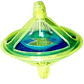
Figure 8. Hydro Gyro

-Objective: The Discovery Place is located in a “kid friendly” section of the museum. The location will allow the FLOAT team to interact with many kids during the visit to the HMNS. Through the use of interactive presentation material, the team hopes to interest kids in learning more about science.

Please see the letter from the HMNS attached in Appendix B in the hard copy version of this document.

3.1.3 The Science Place
FLOAT is also in the planning stages of a trip to The Science Place in Dallas. The Science Place has a mission to “Inspire passion for science through exploration, discovery, and life-long learning.” The FLOAT team feels this will be a perfect opportunity to reach out to children/students in the Dallas area. The same demonstration materials used for the presentation at the HMNS will be brought to The Science Place presentation.

-Objective: The Science Place will offer the opportunity to interact with the youth in the Dallas area and hopefully inspire some young minds to pursue a spurred interest in science and mathematics.

Please see the email John Campbell of The Science Place in Appendix B in the hard copy version of this document.

3.2 Primary and Secondary School Outreach Activities
Museum presentations will allow FLOAT to reach a large and diverse audience. However, a different form of outreach can be achieved by presenting to smaller science class. The FLOAT team plans to travel to local area schools to present the project, demonstrate angular momentum concepts, and interact one-on-one with the students and teachers. Again, the materials used during the museum trips will also be used for school demonstrations. The FLOAT team feels the best way to get kids interested in science and engineering is to get them personally involved in the lesson. Contact has been made with the following schools:

Patricia Nunez, Science Teacher, Sims Elementary School
-presentation date scheduled (Nov. 21, 2003)
Liz Liles, Science Teacher, Covington Middle School
-contact made and presentation dates in work
Leigh Houston, Physics Teacher, Cedar Park High school
-contact made and presentation dates in work

In addition to the Austin area schools, one member of the FLOAT team will be traveling back to his former high school in Arlington, Texas to present. Jay Atman of James Martin High School has agreed to have a FLOAT team member present the FLOAT project during a class period.

-Objective: The main objective of the visits to the various schools will be to excite students about science. With the use of interactive presentation materials, the team hopes to interest the students by making the demonstrations fun but, at the same time, educational. The presentations will be geared to the appropriate technical level based on the age of the students in the audience.

Please see the emails from Jay Atman and Patricia Nunez in Appendix B in the hard copy version of this document.

3.3 Publications
In addition to the planned presentations at various schools and museums, the team has contacted local news media sources about publishing articles about the project. The Vector, a University of Texas engineering newsletter, has agreed to write an article in its upcoming edition about the FLOAT team’s proposed project. It is expected that if the FLOAT project is accepted, the Vector will follow-up this first article with a post-flight installment. FLOAT is also in contact with the daily Austin newspaper, the Austin American Statesman, about writing an article if the team is accepted to fly.

Please see the letter and rough draft of news article from Emily Burrough of the Vector, in Appendix B in the hard copy version of this document.

-Objective: To allow general engineering student to become familiar with the project in hopes of expanding interests in the KC-135A program.

3.4 Team Webpage
The team webpage has been created but is still under construction. The address to the webpage address is:
http://libra.ae.utexas.edu/research/float/

Please note that the UT ASE computer lab is transferring all Unix accounts to Linux servers. Although the link provided here is currently active, it may no longer be the address by the time this section is reviewed. The FLOAT team will provide any web address updates to the program office.

The webpage will continue to be updated throughout the year to incorporate the latest FLOAT team news, pictures, and events. For all outreach events the FLOAT team hosts, documentation containing the website address of the team will be provided to any attendees. Hopefully, the documentation will allow word to spread about the team while also providing an easy FLOAT update source. Once the proposal is submitted to the RGSFOP, it will be uploaded to the webpage for viewing.

-Objective: The webpage’s purpose is primarily to increase the FLOAT project visibility across the world.

4.0 Administrative Requirements
FLOAT recognizes the need for compliance with requirements by NASA including the program timeline, deadlines, and requests for information in order to have a successful RGSFOP experience. The FLOAT team will adhere to these requirements as well as any others requested by NASA.

4.1 Institution’s Letter of Endorsement
Please see the letter from Dr. Robert Bishop, chairman of the Department of Aerospace Engineering and Engineering Mechanics. The letter is attached in Appendix A to the hard copy version of this document.

4.2 Supervising Faculty Statement
Please see the statement from the FLOAT team’s faculty advisor, Dr. Robert Bishop. The statement is attached in Appendix A to the hard copy version of this document.

4.3 Budget
An analysis of the approximate funds to complete the evaluation of the FMC as part of RGSFOP is found in Table 2.
Table 2. Estimated Budget for Texas FLOAT Project
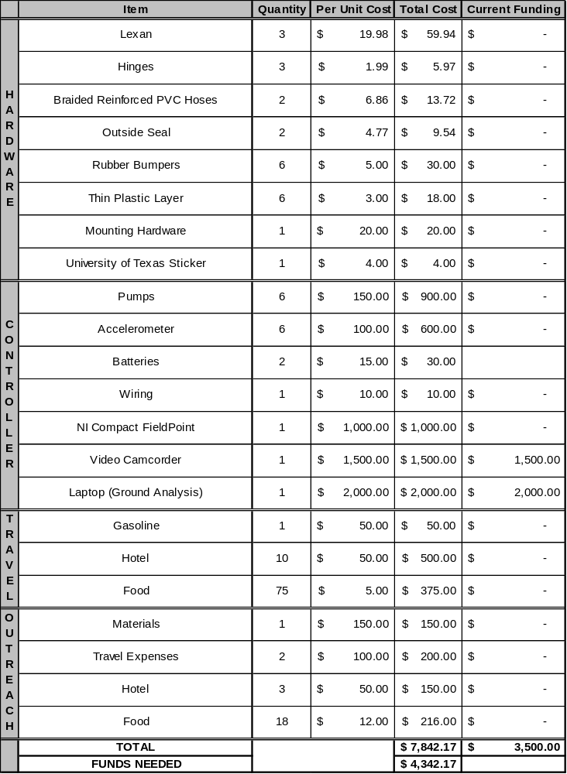

As Table 2 shows, the total budget needed is $7,842.17 and we have received $3,500.00 in contributions. The contributions consist of a laptop and a video camera that has been generously been provided by The University of Texas at Austin’s Department of Aerospace Engineering and Engineering Mechanics. The values for the travel expenses and outreach are approximate. The hardware budget has been estimated according to our preliminary design through Home Depot and various sources on the internet.

4.4 Funding
The Department of Aerospace Engineering at The University of Texas agrees to provide a substantial amount of the FLOAT team’s funding. National Instruments is closely tied to the department and expresses great interest in supporting the needs of undergraduate research. National Instruments has a history of donating equipment for UT KC-135A projects, and the FLOAT team anticipates National Instruments will donate the Compact FieldPoint system. If the FLOAT team is selected for flight, the FLOAT team will approach the pump manufacturer, JABSCO, for additional equipment donations. The Texas Space Grant Consortium will also be contacted for further funding. The department is also closely aligned with industry representatives from The Boeing Company and Lockheed Martin Corporation, two potential sources for funding. The FLOAT team is confident that all expenses will be covered.

4.5 Institutional Review Board
Not applicable.

4.6 Institutional Animal Care and Use Committee
Not applicable.

4.7 Parental Consent Forms
Not applicable.

Appendix A: Institution’s Letter of Endorsement and Supervising Faculty Statement

Appendix B: Outreach Letters of Committal

Appendix C: Specification Sheets for Various Components

Appendix D: MATLAB Moment of Inertia and Angular Momentum Code

Baseline calculations were computed in MATLAB to determine the viability of the FMC. Based on these calculations, the angular displacement achievable in 20 seconds is

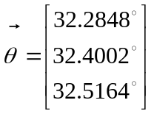

with angular momentum generated by the fluid loops of

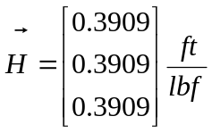

The code that generated these results is seen below.

%Fluid Momentum Controller
%Inertia Tensor Calculations
%Brad Steinfeldt and Amanda Kelly

%The geometry set up is as follows:
%A hollow cube with a fluid loop on the top and bottom face of the cube
%The 6 pumps are located on the faces as shown below
%
% Top Face (looking down from top)
% -------------
% | X |
% | X |
% | X |
% | |
% | |
% | |
% -------------
%
% Bottom Face (looking down from top)
% -------------
% | |
% | |
% | |
% | X |
% | X |
% | X |
% -------------
%
% Left Face (looking from the left of cube)
% -------------
% | X |
% | X |
% | X |
% | |
% | |
% | |
% -------------
%
% Right Face (looking from the left of cube)
% -------------
% | |
% | |
% | |
% | X |
% | X |
% | X |
% -------------
%
% Front Face (looking from the front of cube)
% -------------
% | |
% | |
% | |
% | X |
% | X |
% | X |
% -------------
%
% Back Face (looking from the front of cube)
% -------------
% | X |
% | X |
% | X |
% | |
% | |
% | |
% -------------

%The coordinate axis for the problem is defined to be:
%X-Axis: Out the right face
%Y-Axis: Out the front face
%Z-Axis: Out the top face

%This program assumes the following:
% 1) Rectangular Prisim faces
% 2) The working fluid is evenly distributed mass inside of a torus
% 3) The mass distribution of the plates is even
% 4) The pumps are modeled as rectangular prisms with constant density (probably
% a BAD assumption)
% 5) The connection between the fluid loops and the pumps are done at the end of
% the pumps (i.e. no offset)
% 6) The batteries are massless (BAD assumption)
% 7) The circuit board is massless
% 8) The tubes are negligible in mass
% 9) Everything is symmetric

%The working fluid for the problem is water using a Jabsco 59500 Pump

%%%%%%%%%%%%%%%%%%%%%%%%%%%%%%%%%%%%%%%%%%%%%%%%%%%%%%%%%%%%%%%%%%%%%%%%%%%%%%%%%%%%%%%%%%
%%%%%%%%%%%%%%%%%%%%%%%%%%%%%%%%%%BASIC INERTIA TENSORS%%%%%%%%%%%%%%%%%%%%%%%%%%%%%%%%%%%
%%%%%%%%%%%%%%%%%%%%%%%%%%%%%%%%%%%%%%%%%%%%%%%%%%%%%%%%%%%%%%%%%%%%%%%%%%%%%%%%%%%%%%%%%%

%Rectangular Prism
%
%
% ------------
% /| /| b
% / ---------/-- height=b
% / / / / width=c
% / / / / depth=a
% ----------- / a
% |/ |/ Volume=a*b*c
% -----------
% c
%
% X-Axis: Through center of mass and out the right face
% Y-Axis: Through center of mass and out the top face
% Z-Axis: Through center of mass and out the front face
%
% [ 1/12*M*(a^2+b^2) 0 0 ]
% [ 0 1/12*M*(a^2+c^2) 0 ]
% [ 0 0 1/12*M*(b^2+c^2) ]

%Solid Torus
%
%
% c=radius from the center to the center of the cross sectional area
% a=radius of the cross section (i.e. the circle that is revolved)
%
% X-Axis: A symmetric axis through center of mass
% Y-Axis: A symmetric axis through center of mass
% Z-Axis: Through the center of mass and up
%
% [ 1/8*M*(5*a^2+4*c^2) 0 0 ]
% [ 0 1/8*M*(5*a^2+4*c^2) 0 ]
% [ 0 0 M*(3/4*a^2+c^2) ]

%%%%%%%%%%%%%%%%%%%%%%%%%%%%%%%%%%%%%%%%%%%%%%%%%%%%%%%%%%%%%%%%%%%%%%%%%%%%%%%%%%%%%%%%%%
%%%%%%%%%%%%%%%%%%%%%%%%%%%%%%%%%%%%%%%%INPUT DATA%%%%%%%%%%%%%%%%%%%%%%%%%%%%%%%%%%%%%%%%
%%%%%%%%%%%%%%%%%%%%%%%%%%%%%%%%%%%%%%%%%%%%%%%%%%%%%%%%%%%%%%%%%%%%%%%%%%%%%%%%%%%%%%%%%%

%Variable Definitions

%rhofluid=density of fluid
%rhoface=density of faces
%pumpmass=mass of pump
%lpump=length of pump
%hpump=height of pump
%wpump=width of pump
%lface=length of faces
%dface=depth of faces
%Q=volumetric flow rate
%innertube=inner diameter of tubing
%outertube=outer diameter of tubing
%innerloop=inner radius of loop
%outerloop=outer radius of loop

rhofluid=62.3707;
rhoface=74.3;
pumpmass=.8;
lpump=5.75/12;
hpump=2.5/12;
wpump=(3+3/8)/12;
lface=1;
dface=.125;
Q=0.00868923615;
innertube=.75/12;
outertube=(.75+1/8)/12;
innerloop=.458333333333;
outerloop=0.5;

%%%%%%%%%%%%%%%%%%%%%%%%%%%%%%%%%%%%%%%%%%%%%%%%%%%%%%%%%%%%%%%%%%%%%%%%%%%%%%%%%%%%%%%%%%
%%%%%%%%%%%%%%%%%%%%%%%%%%%%%%%%%%%%%%%CALCULATIONS%%%%%%%%%%%%%%%%%%%%%%%%%%%%%%%%%%%%%%%
%%%%%%%%%%%%%%%%%%%%%%%%%%%%%%%%%%%%%%%%%%%%%%%%%%%%%%%%%%%%%%%%%%%%%%%%%%%%%%%%%%%%%%%%%%

%%%%%%%%%%%%%%%%%%%%%%%%%%%%%%%%%%%%%%%LOCAL FRAME%%%%%%%%%%%%%%%%%%%%%%%%%%%%%%%%%%%%%%%%

massofface=rhoface*lface^2*dface;

%Bottom Face Inertia (local frame, looking from top of box, x-right, y-down, z-out)
Ibottomface=zeros(3,3);
Ibottomface(1,1)=Ibottomface(1,1)+1/12*massofface*(lface^2+dface^2);
Ibottomface(2,2)=Ibottomface(2,2)+1/12*massofface*(dface^2+lface^2);
Ibottomface(3,3)=Ibottomface(3,3)+1/12*massofface*(lface^2+lface^2);
Ibottomface;

%Top Face Inertia (local frame, looking from top of box, x-right, y-down, z-out)
%Itop=Ibottom
Itopface=Ibottomface;

%Front Face Intertia (local frame, looking from top of box, x-right, y-down, z-out)
Ifrontface=zeros(3,3);
Ifrontface(1,1)=Ifrontface(1,1)+1/12*massofface*(dface^2+lface^2);
Ifrontface(2,2)=Ifrontface(2,2)+1/12*massofface*(lface^2+lface^2);
Ifrontface(3,3)=Ifrontface(3,3)+1/12*massofface*(lface^2+dface^2);
Ifrontface;

%Back Face Inertia (local frame, looking from top of box, x-right, y-down, z-out)
%Iback=Ifront
Ibackface=Ifrontface;

%Left Face Intertia (local frame, looking from top of box, x-right, y-down, z-out)
Ileftface=zeros(3,3);
Ileftface(1,1)=Ileftface(1,1)+1/12*massofface*(lface^2+lface^2);
Ileftface(2,2)=Ileftface(2,2)+1/12*massofface*(lface^2+dface^2);
Ileftface(3,3)=Ileftface(3,3)+1/12*massofface*(dface^2+lface^2);
Ileftface;

%Right Face Inertia (local frame, looking from top of box, x-right, y-down, z-out)
%Iright=Ileft
Irightface=Ileftface;

%Top Torus Inertia (local frame, looking from top of box, x-right, y-down, z-out)
Itoptorus=zeros(3,3);
c=(outerloop-innerloop)/2;
a=innertube/2;
Itoptorus(1,1)=Itoptorus(1,1)+1/8*((5*a^2+4*c^2))*rhofluid*2*pi^2*a^2*c^2;
Itoptorus(2,2)=Itoptorus(2,2)+1/8*((5*a^2+4*c^2))*rhofluid*2*pi^2*a^2*c^2;
Itoptorus(3,3)=Itoptorus(3,3)+(3/4*a^2+c^2)*rhofluid*2*pi^2*a^2*c^2;
Itoptorus;

%Bottom Torus Inertia (local frame, looking from top of box, x-right, y-down, z-out)
%Ibottom=Itop (symmetry)
Ibottomtorus=Itoptorus;

%Back Torus Inertia (local frame, looking from top of box, x-right, y-down, z-out)
Ibacktorus=zeros(3,3);
c=(outerloop-innerloop)/2;
a=innertube/2;
Ibacktorus(1,1)=Ibacktorus(1,1)+1/8*((5*a^2+4*c^2))*rhofluid*2*pi^2*a^2*c^2;
Ibacktorus(2,2)=Ibacktorus(3,3)+(3/4*a^2+c^2)*rhofluid*2*pi^2*a^2*c^2;
Ibacktorus(3,3)=Ibacktorus(2,2)+1/8*((5*a^2+4*c^2))*rhofluid*2*pi^2*a^2*c^2;
Ibacktorus;

%Front Torus Inertia (local frame, looking from top of box, x-right, y-down, z-out)
%Ifront=Iback (symmetry)
Ifronttorus=Ibacktorus;

%Left Torus Inertia (local frame, looking from top of box, x-right, y-down, z-out)
Ilefttorus=zeros(3,3);
c=(outerloop-innerloop)/2;
a=innertube/2;
Ilefttorus(1,1)=Ilefttorus(3,3)+(3/4*a^2+c^2)*rhofluid*2*pi^2*a^2*c^2;
Ilefttorus(2,2)=Ilefttorus(1,1)+1/8*((5*a^2+4*c^2))*rhofluid*2*pi^2*a^2*c^2;
Ilefttorus(3,3)=Ilefttorus(2,2)+1/8*((5*a^2+4*c^2))*rhofluid*2*pi^2*a^2*c^2;
Ilefttorus;

%Right Torus Inertia (local frame, looking from top of box, x-right, y-down, z-out)
%Iright=Ileft (symmetry)
Irighttorus=Ilefttorus;

%Top Pump Inertia (local frame, looking from top of box, x-right, y-down, z-out)
Itoppump=zeros(3,3);
Itoppump(1,1)=Itoppump(1,1)+1/12*pumpmass*(lpump^2+hpump^2);
Itoppump(2,2)=Itoppump(2,2)+1/12*pumpmass*(wpump^2+hpump^2);
Itoppump(3,3)=Itoppump(3,3)+1/12*pumpmass*(lpump^2+wpump^2);
Itoppump;

%Bottom Pump Inertia (local frame, looking from top of box, x-right, y-down, z-out)
%Ibottom=Itop
Ibottompump=Itoppump;

%Left Pump Inertia (local frame, looking from top of box, x-right, y-down, z-out)
Ileftpump=zeros(3,3);
Ileftpump(1,1)=Ileftpump(1,1)+1/12*pumpmass*(lpump^2+wpump^2);
Ileftpump(2,2)=Ileftpump(2,2)+1/12*pumpmass*(hpump^2+lpump^2);
Ileftpump(3,3)=Ileftpump(3,3)+1/12*pumpmass*(hpump^2+wpump^2);
Ileftpump;

%Right Pump Inertia (local frame, looking from top of box, x-right, y-down, z-out)
%Iright=Ileft
Irightpump=Ileftpump;

%Front Pump Inertia (local frame, looking from top of box, x-right, y-down, z-out)
Ifrontpump=zeros(3,3);
Ifrontpump(1,1)=Ifrontpump(1,1)+1/12*pumpmass*(lpump^2+hpump^2);
Ifrontpump(2,2)=Ifrontpump(2,2)+1/12*pumpmass*(wpump^2+lpump^2);
Ifrontpump(3,3)=Ifrontpump(3,3)+1/12*pumpmass*(wpump^2+hpump^2);
Ifrontpump;

%Back Pump Inertia (local frame, looking from top of box, x-right, y-down, z-out)
%Iback=Ifront
Ibackpump=Ifrontpump;

%%%%%%%%%%%%%%%%%%%%%%%%%%%%%%%%%%%%%%%GLOBAL FRAME%%%%%%%%%%%%%%%%%%%%%%%%%%%%%%%%%%%%%%%

%Intialize Inertia Tensor

I=zeros(3,3);

%%%%%%%%%%%%%%%%%%%%%%%%%%%%%%%%%%%%%%%%ADD FACES%%%%%%%%%%%%%%%%%%%%%%%%%%%%%%%%%%%%%%%%%

%Bottom face
dx=0;
dy=0;
dz=(lface-dface)/2;
I(1,1)=I(1,1)+Ibottomface(1,1)+(dy^2+dz^2)*massofface;
I(1,2)=-1*(I(1,2)+Ibottomface(1,2)+(dx*dy)*massofface);
I(1,3)=-1*(I(1,3)+Ibottomface(1,3)+(dx*dz)*massofface);
I(2,1)=-1*(I(2,1)+Ibottomface(2,1)+(dx*dy)*massofface);
I(2,2)=I(2,2)+Ibottomface(2,2)+(dx^2+dz^2)*massofface;
I(2,3)=-1*(I(2,3)+Ibottomface(2,3)+(dy*dz)*massofface);
I(3,1)=-1*(I(3,1)+Ibottomface(3,1)+(dz*dx)*massofface);
I(3,2)=-1*(I(3,2)+Ibottomface(3,2)+(dz*dy)*massofface);
I(3,3)=I(3,3)+Ibottomface(3,3)+(dx^2+dy^2)*massofface;
I;

%Top face
dx=0;
dy=0;
dz=-(lface-dface)/2;
I(1,1)=I(1,1)+Itopface(1,1)+(dy^2+dz^2)*massofface;
I(1,2)=-1*(I(1,2)+Itopface(1,2)+(dx*dy)*massofface);
I(1,3)=-1*(I(1,3)+Itopface(1,3)+(dx*dz)*massofface);
I(2,1)=-1*(I(2,1)+Itopface(2,1)+(dx*dy)*massofface);
I(2,2)=I(2,2)+Itopface(2,2)+(dx^2+dz^2)*massofface;
I(2,3)=-1*(I(2,3)+Itopface(2,3)+(dy*dz)*massofface);
I(3,1)=-1*(I(3,1)+Itopface(3,1)+(dz*dx)*massofface);
I(3,2)=-1*(I(3,2)+Itopface(3,2)+(dz*dy)*massofface);
I(3,3)=I(3,3)+Itopface(3,3)+(dx^2+dy^2)*massofface;
I;

%Left face
dx=(lface-dface)/2;
dy=0;
dz=0;
I(1,1)=I(1,1)+Ileftface(1,1)+(dy^2+dz^2)*massofface;
I(1,2)=-1*(I(1,2)+Ileftface(1,2)+(dx*dy)*massofface);
I(1,3)=-1*(I(1,3)+Ileftface(1,3)+(dx*dz)*massofface);
I(2,1)=-1*(I(2,1)+Ileftface(2,1)+(dx*dy)*massofface);
I(2,2)=I(2,2)+Ileftface(2,2)+(dx^2+dz^2)*massofface;
I(2,3)=-1*(I(2,3)+Ileftface(2,3)+(dy*dz)*massofface);
I(3,1)=-1*(I(3,1)+Ileftface(3,1)+(dz*dx)*massofface);
I(3,2)=-1*(I(3,2)+Ileftface(3,2)+(dz*dy)*massofface);
I(3,3)=I(3,3)+Ileftface(3,3)+(dx^2+dy^2)*massofface;
I;

%Right face
dx=-(lface-dface)/2;
dy=0;
dz=0;
I(1,1)=I(1,1)+Irightface(1,1)+(dy^2+dz^2)*massofface;
I(1,2)=-1*(I(1,2)+Irightface(1,2)+(dx*dy)*massofface);
I(1,3)=-1*(I(1,3)+Irightface(1,3)+(dx*dz)*massofface);
I(2,1)=-1*(I(2,1)+Irightface(2,1)+(dx*dy)*massofface);
I(2,2)=I(2,2)+Irightface(2,2)+(dx^2+dz^2)*massofface;
I(2,3)=-1*(I(2,3)+Irightface(2,3)+(dy*dz)*massofface);
I(3,1)=-1*(I(3,1)+Irightface(3,1)+(dz*dx)*massofface);
I(3,2)=-1*(I(3,2)+Irightface(3,2)+(dz*dy)*massofface);
I(3,3)=I(3,3)+Irightface(3,3)+(dx^2+dy^2)*massofface;
I;

%Front face
dx=0;
dy=-(lface-dface)/2;
dz=0;
I(1,1)=I(1,1)+Ifrontface(1,1)+(dy^2+dz^2)*massofface;
I(1,2)=-1*(I(1,2)+Ifrontface(1,2)+(dx*dy)*massofface);
I(1,3)=-1*(I(1,3)+Ifrontface(1,3)+(dx*dz)*massofface);
I(2,1)=-1*(I(2,1)+Ifrontface(2,1)+(dx*dy)*massofface);
I(2,2)=I(2,2)+Ifrontface(2,2)+(dx^2+dz^2)*massofface;
I(2,3)=-1*(I(2,3)+Ifrontface(2,3)+(dy*dz)*massofface);
I(3,1)=-1*(I(3,1)+Ifrontface(3,1)+(dz*dx)*massofface);
I(3,2)=-1*(I(3,2)+Ifrontface(3,2)+(dz*dy)*massofface);
I(3,3)=I(3,3)+Ifrontface(3,3)+(dx^2+dy^2)*massofface;
I;

%Back face
dx=0;
dy=(lface-dface)/2;
dz=0;
I(1,1)=I(1,1)+Ibackface(1,1)+(dy^2+dz^2)*massofface;
I(1,2)=-1*(I(1,2)+Ibackface(1,2)+(dx*dy)*massofface);
I(1,3)=-1*(I(1,3)+Ibackface(1,3)+(dx*dz)*massofface);
I(2,1)=-1*(I(2,1)+Ibackface(2,1)+(dx*dy)*massofface);
I(2,2)=I(2,2)+Ibackface(2,2)+(dx^2+dz^2)*massofface;
I(2,3)=-1*(I(2,3)+Ibackface(2,3)+(dy*dz)*massofface);
I(3,1)=-1*(I(3,1)+Ibackface(3,1)+(dz*dx)*massofface);
I(3,2)=-1*(I(3,2)+Ibackface(3,2)+(dz*dy)*massofface);
I(3,3)=I(3,3)+Ibackface(3,3)+(dx^2+dy^2)*massofface;
I;

%%%%%%%%%%%%%%%%%%%%%%%%%%%%%%%%%%%%%%%%ADD LOOPS%%%%%%%%%%%%%%%%%%%%%%%%%%%%%%%%%%%%%%%%%

massofloop=rhofluid*pi/4*innertube^2;

%Bottom Loop
dx=0;
dy=0;
dz=lface/2-outertube/2-dface;
I(1,1)=I(1,1)+Ibottomtorus(1,1)+(dy^2+dz^2)*massofloop;
I(1,2)=-1*(I(1,2)+Ibottomtorus(1,2)+(dx*dy)*massofloop);
I(1,3)=-1*(I(1,3)+Ibottomtorus(1,3)+(dx*dz)*massofloop);
I(2,1)=-1*(I(2,1)+Ibottomtorus(2,1)+(dx*dy)*massofloop);
I(2,2)=I(2,2)+Ibottomtorus(2,2)+(dx^2+dz^2)*massofloop;
I(2,3)=-1*(I(2,3)+Ibottomtorus(2,3)+(dy*dz)*massofloop);
I(3,1)=-1*(I(3,1)+Ibottomtorus(3,1)+(dz*dx)*massofloop);
I(3,2)=-1*(I(3,2)+Ibottomtorus(3,2)+(dz*dy)*massofloop);
I(3,3)=I(3,3)+Ibottomtorus(3,3)+(dx^2+dy^2)*massofloop;
I;

%Top Loop
dx=0;
dy=0;
dz=-(lface/2-outertube/2-dface);
I(1,1)=I(1,1)+Itoptorus(1,1)+(dy^2+dz^2)*massofloop;
I(1,2)=-1*(I(1,2)+Itoptorus(1,2)+(dx*dy)*massofloop);
I(1,3)=-1*(I(1,3)+Itoptorus(1,3)+(dx*dz)*massofloop);
I(2,1)=-1*(I(2,1)+Itoptorus(2,1)+(dx*dy)*massofloop);
I(2,2)=I(2,2)+Itoptorus(2,2)+(dx^2+dz^2)*massofloop;
I(2,3)=-1*(I(2,3)+Itoptorus(2,3)+(dy*dz)*massofloop);
I(3,1)=-1*(I(3,1)+Itoptorus(3,1)+(dz*dx)*massofloop);
I(3,2)=-1*(I(3,2)+Itoptorus(3,2)+(dz*dy)*massofloop);
I(3,3)=I(3,3)+Itoptorus(3,3)+(dx^2+dy^2)*massofloop;
I;

%Back Loop
dx=0;
dy=lface/2-outertube/2-dface;
dz=0;
I(1,1)=I(1,1)+Ibacktorus(1,1)+(dy^2+dz^2)*massofloop;
I(1,2)=-1*(I(1,2)+Ibacktorus(1,2)+(dx*dy)*massofloop);
I(1,3)=-1*(I(1,3)+Ibacktorus(1,3)+(dx*dz)*massofloop);
I(2,1)=-1*(I(2,1)+Ibacktorus(2,1)+(dx*dy)*massofloop);
I(2,2)=I(2,2)+Ibacktorus(2,2)+(dx^2+dz^2)*massofloop;
I(2,3)=-1*(I(2,3)+Ibacktorus(2,3)+(dy*dz)*massofloop);
I(3,1)=-1*(I(3,1)+Ibacktorus(3,1)+(dz*dx)*massofloop);
I(3,2)=-1*(I(3,2)+Ibacktorus(3,2)+(dz*dy)*massofloop);
I(3,3)=I(3,3)+Ibacktorus(3,3)+(dx^2+dy^2)*massofloop;
I;

%Front Loop
dx=0;
dy=-(lface/2-outertube/2-dface);
dz=0;
I(1,1)=I(1,1)+Ifronttorus(1,1)+(dy^2+dz^2)*massofloop;
I(1,2)=-1*(I(1,2)+Ifronttorus(1,2)+(dx*dy)*massofloop);
I(1,3)=-1*(I(1,3)+Ifronttorus(1,3)+(dx*dz)*massofloop);
I(2,1)=-1*(I(2,1)+Ifronttorus(2,1)+(dx*dy)*massofloop);
I(2,2)=I(2,2)+Ifronttorus(2,2)+(dx^2+dz^2)*massofloop;
I(2,3)=-1*(I(2,3)+Ifronttorus(2,3)+(dy*dz)*massofloop);
I(3,1)=-1*(I(3,1)+Ifronttorus(3,1)+(dz*dx)*massofloop);
I(3,2)=-1*(I(3,2)+Ifronttorus(3,2)+(dz*dy)*massofloop);
I(3,3)=I(3,3)+Ifronttorus(3,3)+(dx^2+dy^2)*massofloop;
I;

%Left Loop
dx=lface/2-outertube/2-dface;
dy=0;
dz=0;
I(1,1)=I(1,1)+Ilefttorus(1,1)+(dy^2+dz^2)*massofloop;
I(1,2)=-1*(I(1,2)+Ilefttorus(1,2)+(dx*dy)*massofloop);
I(1,3)=-1*(I(1,3)+Ilefttorus(1,3)+(dx*dz)*massofloop);
I(2,1)=-1*(I(2,1)+Ilefttorus(2,1)+(dx*dy)*massofloop);
I(2,2)=I(2,2)+Ilefttorus(2,2)+(dx^2+dz^2)*massofloop;
I(2,3)=-1*(I(2,3)+Ilefttorus(2,3)+(dy*dz)*massofloop);
I(3,1)=-1*(I(3,1)+Ilefttorus(3,1)+(dz*dx)*massofloop);
I(3,2)=-1*(I(3,2)+Ilefttorus(3,2)+(dz*dy)*massofloop);
I(3,3)=I(3,3)+Ilefttorus(3,3)+(dx^2+dy^2)*massofloop;
I;

%Right Loop
dx=-(lface/2-outertube/2-dface);
dy=0;
dz=0;
I(1,1)=I(1,1)+Irighttorus(1,1)+(dy^2+dz^2)*massofloop;
I(1,2)=-1*(I(1,2)+Irighttorus(1,2)+(dx*dy)*massofloop);
I(1,3)=-1*(I(1,3)+Irighttorus(1,3)+(dx*dz)*massofloop);
I(2,1)=-1*(I(2,1)+Irighttorus(2,1)+(dx*dy)*massofloop);
I(2,2)=I(2,2)+Irighttorus(2,2)+(dx^2+dz^2)*massofloop;
I(2,3)=-1*(I(2,3)+Irighttorus(2,3)+(dy*dz)*massofloop);
I(3,1)=-1*(I(3,1)+Irighttorus(3,1)+(dz*dx)*massofloop);
I(3,2)=-1*(I(3,2)+Irighttorus(3,2)+(dz*dy)*massofloop);
I(3,3)=I(3,3)+Irighttorus(3,3)+(dx^2+dy^2)*massofloop;
I;

%%%%%%%%%%%%%%%%%%%%%%%%%%%%%%%%%%%%%%%%ADD PUMPS%%%%%%%%%%%%%%%%%%%%%%%%%%%%%%%%%%%%%%%%%

%Bottom Pump
dx=0;
dy=-(lface/2-dface-lpump/2);
dz=lface/2-dface-hpump/2;
I(1,1)=I(1,1)+Ibottompump(1,1)+(dy^2+dz^2)*pumpmass;
I(1,2)=-1*(I(1,2)+Ibottompump(1,2)+(dx*dy)*pumpmass);
I(1,3)=-1*(I(1,3)+Ibottompump(1,3)+(dx*dz)*pumpmass);
I(2,1)=-1*(I(2,1)+Ibottompump(2,1)+(dx*dy)*pumpmass);
I(2,2)=I(2,2)+Ibottompump(2,2)+(dx^2+dz^2)*pumpmass;
I(2,3)=-1*(I(2,3)+Ibottompump(2,3)+(dy*dz)*pumpmass);
I(3,1)=-1*(I(3,1)+Ibottompump(3,1)+(dz*dx)*pumpmass);
I(3,2)=-1*(I(3,2)+Ibottompump(3,2)+(dz*dy)*pumpmass);
I(3,3)=I(3,3)+Ibottompump(3,3)+(dx^2+dy^2)*pumpmass;
I;

%Top Pump
dx=0;
dy=lface/2-dface-lpump/2;
dz=-(lface/2-dface-hpump/2);
I(1,1)=I(1,1)+Itoppump(1,1)+(dy^2+dz^2)*pumpmass;
I(1,2)=-1*(I(1,2)+Itoppump(1,2)+(dx*dy)*pumpmass);
I(1,3)=-1*(I(1,3)+Itoppump(1,3)+(dx*dz)*pumpmass);
I(2,1)=-1*(I(2,1)+Itoppump(2,1)+(dx*dy)*pumpmass);
I(2,2)=I(2,2)+Itoppump(2,2)+(dx^2+dz^2)*pumpmass;
I(2,3)=-1*(I(2,3)+Itoppump(2,3)+(dy*dz)*pumpmass);
I(3,1)=-1*(I(3,1)+Itoppump(3,1)+(dz*dx)*pumpmass);
I(3,2)=-1*(I(3,2)+Itoppump(3,2)+(dz*dy)*pumpmass);
I(3,3)=I(3,3)+Itoppump(3,3)+(dx^2+dy^2)*pumpmass;
I;

%Left Pump
dx=lface/2-dface-hpump/2;
dy=0;
dz=-(lface/2-dface-lpump/2);
I(1,1)=I(1,1)+Ileftpump(1,1)+(dy^2+dz^2)*pumpmass;
I(1,2)=-1*(I(1,2)+Ileftpump(1,2)+(dx*dy)*pumpmass);
I(1,3)=-1*(I(1,3)+Ileftpump(1,3)+(dx*dz)*pumpmass);
I(2,1)=-1*(I(2,1)+Ileftpump(2,1)+(dx*dy)*pumpmass);
I(2,2)=I(2,2)+Ileftpump(2,2)+(dx^2+dz^2)*pumpmass;
I(2,3)=-1*(I(2,3)+Ileftpump(2,3)+(dy*dz)*pumpmass);
I(3,1)=-1*(I(3,1)+Ileftpump(3,1)+(dz*dx)*pumpmass);
I(3,2)=-1*(I(3,2)+Ileftpump(3,2)+(dz*dy)*pumpmass);
I(3,3)=I(3,3)+Ileftpump(3,3)+(dx^2+dy^2)*pumpmass;
I;

%Right Pump
dx=-(lface/2-dface-hpump/2);
dy=0;
dz=lface/2-dface-lpump/2;
I(1,1)=I(1,1)+Irightpump(1,1)+(dy^2+dz^2)*pumpmass;
I(1,2)=-1*(I(1,2)+Irightpump(1,2)+(dx*dy)*pumpmass);
I(1,3)=-1*(I(1,3)+Irightpump(1,3)+(dx*dz)*pumpmass);
I(2,1)=-1*(I(2,1)+Irightpump(2,1)+(dx*dy)*pumpmass);
I(2,2)=I(2,2)+Irightpump(2,2)+(dx^2+dz^2)*pumpmass;
I(2,3)=-1*(I(2,3)+Irightpump(2,3)+(dy*dz)*pumpmass);
I(3,1)=-1*(I(3,1)+Irightpump(3,1)+(dz*dx)*pumpmass);
I(3,2)=-1*(I(3,2)+Irightpump(3,2)+(dz*dy)*pumpmass);
I(3,3)=I(3,3)+Irightpump(3,3)+(dx^2+dy^2)*pumpmass;
I;

%Front Pump
dx=0;
dy=-(lface/2-dface-hpump/2);
dz=lface/2-dface-lpump/2;
I(1,1)=I(1,1)+Ifrontpump(1,1)+(dy^2+dz^2)*pumpmass;
I(1,2)=-1*(I(1,2)+Ifrontpump(1,2)+(dx*dy)*pumpmass);
I(1,3)=-1*(I(1,3)+Ifrontpump(1,3)+(dx*dz)*pumpmass);
I(2,1)=-1*(I(2,1)+Ifrontpump(2,1)+(dx*dy)*pumpmass);
I(2,2)=I(2,2)+Ifrontpump(2,2)+(dx^2+dz^2)*pumpmass;
I(2,3)=-1*(I(2,3)+Ifrontpump(2,3)+(dy*dz)*pumpmass);
I(3,1)=-1*(I(3,1)+Ifrontpump(3,1)+(dz*dx)*pumpmass);
I(3,2)=-1*(I(3,2)+Ifrontpump(3,2)+(dz*dy)*pumpmass);
I(3,3)=I(3,3)+Ifrontpump(3,3)+(dx^2+dy^2)*pumpmass;
I;

%Back Pump
dx=0;
dy=lface/2-dface-hpump/2;
dz=-(lface/2-dface-lpump/2);
I(1,1)=I(1,1)+Ibackpump(1,1)+(dy^2+dz^2)*pumpmass;
I(1,2)=-1*(I(1,2)+Ibackpump(1,2)+(dx*dy)*pumpmass);
I(1,3)=-1*(I(1,3)+Ibackpump(1,3)+(dx*dz)*pumpmass);
I(2,1)=-1*(I(2,1)+Ibackpump(2,1)+(dx*dy)*pumpmass);
I(2,2)=I(2,2)+Ibackpump(2,2)+(dx^2+dz^2)*pumpmass;
I(2,3)=-1*(I(2,3)+Ibackpump(2,3)+(dy*dz)*pumpmass);
I(3,1)=-1*(I(3,1)+Ibackpump(3,1)+(dz*dx)*pumpmass);
I(3,2)=-1*(I(3,2)+Ibackpump(3,2)+(dz*dy)*pumpmass);
I(3,3)=I(3,3)+Ibackpump(3,3)+(dx^2+dy^2)*pumpmass;
I;

%%%%%%%%%%%%%%%%%%%%%%%%%%%%%%%%%%%%%%%%%%%%%%%%%%%%%%%%%%%%%%%%%%%%%%%%%%%%%%%%%%%%%%%%%%
%%%%%%%%%%%%%%%%%%%%%%%%%%%%%%%%%%%%%%%OUTPUT DATA%%%%%%%%%%%%%%%%%%%%%%%%%%%%%%%%%%%%%%%%
%%%%%%%%%%%%%%%%%%%%%%%%%%%%%%%%%%%%%%%%%%%%%%%%%%%%%%%%%%%%%%%%%%%%%%%%%%%%%%%%%%%%%%%%%%

H=[pi*rhofluid*((outerloop+innerloop)/2)^2*Q;pi*rhofluid*((outerloop+innerloop)/2)^2*Q;pi*rhofluid*((outerloop+innerloop)/2)^2*Q]
omega=I\H;
omegadeg=omega*180/pi;
omegadeg20=omegadeg*20

H =

0.3909
0.3909
0.3909

omegadeg20 =

32.2848
32.4002
32.5164

